Curriculum Vitae of Gretha Helberg | 2024
Spiritual art, which is ALL true creative art, fills the senses and soul with a being, life beyond our own. Part of God’s creation, yet reflecting it in a new way, one that takes our imaginations and passions into new places. For artists are explorers. We find, search, out there but also inward. We need to create, but it must have purpose, for all.  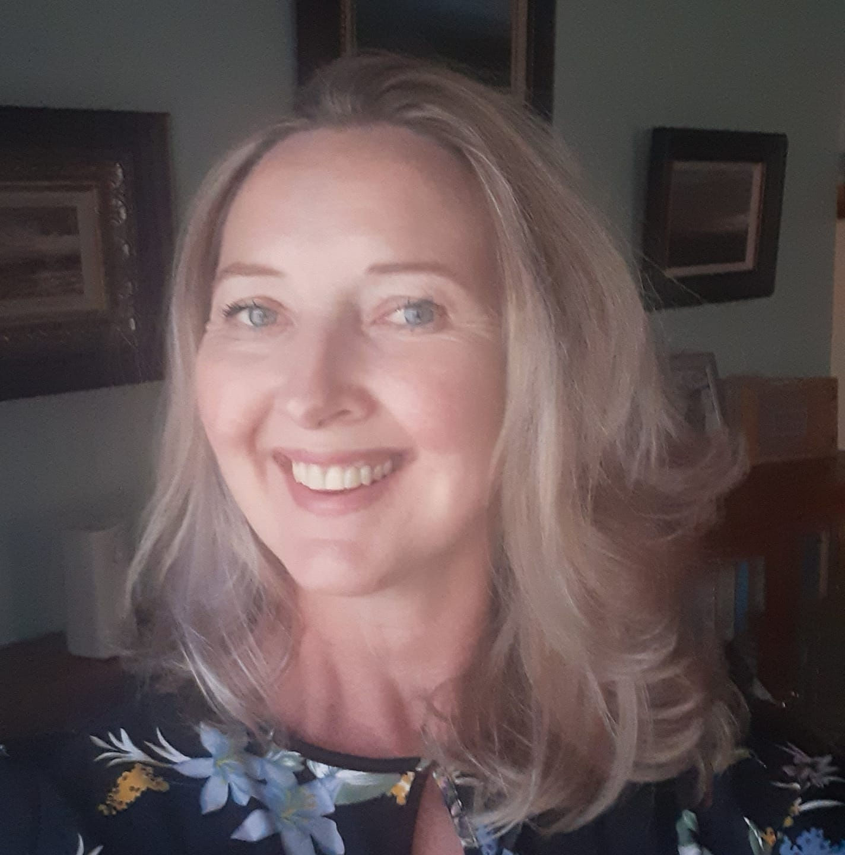 |  | My journey as an artist…

Gretha Helberg (néé Bekker), was born on 2 March 1976 in Rhodesia (now Zimbabwe). She was 2 years old when her parents moved back to South Africa in 1978. She is a South African Resident.

Herewith a summary of her achievements in art and exhibitions:
- 1993, June: Received a TED Art Festival Certificate for work exhibited.
- 1993, Sept: Completed a year course in printmaking at De Wijk Art studio in Hartbeespoort, her
former art teacher, Braam van Wyk’s studio. Here she learned all the aspects of printmaking, such as hard ground etching, aquatint, collography, screen printing, tilography and other techniques.
- 1994: Received the Madie Burger floating trophy for the most diligent art student in Matric.
- 1994: Exhibited, as part of a group exhibition, at the Rendezvoux Art Gallery in Hartbeespoort.
- 1994: Received a book price, a hand printed “Frans Claerhout, Morwa La Lerato” book no. 225 for the
Best Achievement in Art, Std. 10 (now Grade 12).
- 1994: Matriculated at Hartbeespoort Secondary School with a distinction in Art and Afrikaans.
- 1995 – 97: Obtained a BA (Art Direction) degree at the PU for CHE (now North West University).
History of Art and Graphic Design were the main subjects.
- 1998-2000: Worked as graphic designer at print shops and advertising agencies in Pretoria to
gain experience in the graphic design and print industry.
- 2007, Oct: Exhibited as part of a group exhibition at Portchie’s “Fresh Talent” exhibition at his
gallery in Pretoria.
- 2008, Oct: Completed a course in hard ground etching, soft ground etching and aquatint at the
Ruth Prowse School of Art, Woodstock, Cape Town.
- 2009, March: Completed a 2-day course in cement sculpturing at Eve’s place in Gordon’s Bay, Cape Town.
- 2009, July: Completed a 1 day workshop in lino-cutting by Theo Paul Vorster at the Rust-en-Vrede
Art Gallery, Durbanville, Cape Town.
- 2009: Attended informal art classes in oil painting at the late Jan Visser’s studio in Paternoster.
- 2009-2010: Attended informal ceramic sculpture classes at Dianne Heesom-Greene’s studio,
“Stonefish Gallery” in Paternoster.
- 2010, Aug: Were invited by “Die Kunshuys”, Clanwilliam to be part of a group exhibition for the
annual Flower Festival.
- 2010, Sept: Were invited by Anthea Delmotte to exhibit, as part of a group exhibition, at her
gallery, Anthea Delmotte Gallery, in Piketberg.
- 2011-2012 Attend weekly pottery classes at Laura Lee’s pottery studio in Jacobs Bay.
- 2012, March: Opening of her own gallery in Hopefield, “Pêrels & Pampoene Kunsgalery / Art Gallery”
- 2013, March: Exhibited her art and photography at the KKNK.
- 2013, May: Exhibited at SASA’s (South African Society of Artists) Members 1 Exhibition.
- 2013, Aug: Exhibited at SASA’s (South African Society of Artists) Members 2 Exhibition.
- 2013, Oct: Exhibited at SASA’s 107th Annual Exhibition at Kirstenbosch Gardens, Cape Town.
- 2014, April: First solo exhibition, called “Momente” at 2014 KKNK.
- 2014, July: Exhibited at Art.b Gallery in Bellville as part of a group exhibition, called “TINY TREASURES”.
- 2014, Aug.: Exhibited at “This is me” exhibition at Art on Track, Calitzdorp.
- 2014, Sept: Exhibited at Art Xpo at Riebeek West.
- 2014, Sept: Exhibited at Tulbagh Arts Festival.
- 2015, April: Exhibited at 2015 KKNK, “Land & See”.
- 2015, May: My artwork has been published in: „Internationale Kunst Heute – 2015“. One of 127 artists.
- 2015, July: Exhibited at Innibos, Nelspruit.
- 2015, Aug: Solo exhibition in Langebaan, at the Art Square, called “Atmosphere”.
- 2015, Dec: Exhibited 4 works at “Little Treasures 2015” in Bologna, Italy, organized by Trevisan International Art.
- 2016, Jan: Five of her works has been selected by Portraits Africa, in Amsterdam, Netherlands, to be reproduced as limited edition high quality prints, printed in London, UK, by EN1 Prints.
- 2016, April: Exhibited at 2016 KKNK.
- 2016, June: Exhibited at the Gauteng Fine Art Fair.
- 2016, July: Exhibited at Innibos 2016.
- 2016, Aug: Solo exhibition, “Sensuality” at R-Café in Cape Town.
- 2016, Oct: Participated in a group exhibition in Jacobsbaai.
- 2016, Dec: Participated in “Art Elite” group exhibition called “West Coast Art Fair” in Saldanha Bay, Paternoster and Langebaan.
- 2017, Apr. Participated in a group exhibition called “A Visual Requiem for Judith Mason”, in Tulbagh.
- 2017, July: Participated in a group exhibition called “Requiem” at Monéir Gallery in Pringle Bay.
- 2017, July: Participated in a group exhibition called “7 Works for Peace” at Vredenvlucht Venue, Randfontein.
- ‘17, Jul-Aug: Retrospective solo exhibition of her work over the course of 23 years, in association with the local radio station, “Perron FM 95.1”, called “Retrospektief” at Malmesbury Museum.
- 2017, July: Participated in a group exhibition called “7 Works for Peace” at Vredenvlucht Venue, Randfontein
- 2017, Okt: Participated in a group exhibition called “The Rituals of Marriage - A Dialogue With Christo Coetzee, Christo Coetzee Museum & Galery, Tulbagh.
- 2017, Dec: Participated in a group exhibition called “The Gift of Art” at Mullers Gallery, Longmarket Street, Cape Town.
- 2018, Jan: Participated in a group exhibition called “Our Waterwise Environment” at the Art Square, Langebaan.
- July, 2018: Many Hands Winter Art Exhibition at Pecanwood Estate, Hartbeespoort in die Clubhouse Ballroom.
- Aug.- Oct: Participating in “Re-Art meets Africa” exhibition in Ihlienworth near Hamburg, Germany. Five of my polymer etchings were selected for this prestige exhibition.
- 29 Sept: Freedom in Art Exhibition at the Castle of Good Hope, Cape Town
- Nov 2018: Participated at Greyton Art Walk.
- KKNK 2019: Exhibited at KKNK25 as part of a group exhibition of West Coast Artists, organized by Blissfully Anna Gallery of Arts.
- Oct, 2019: Exhibited at the XIIth Florence Biennale at the Fortezza da Basso, Florence – Italy (18-27 October 2019).
- Nov 2019: Open my own art gallery in the Art Shed, Paternoster.
- June-Sept 2020: Participating in an International Virtual Engravist Printmaking Biennial in the Burgundy Hall.
- March 2022: Exhibit together with my mother, “Mother and Daughter” exhibition at the KKNK.
- July 2023: Pop up gallery of my art at Oaks on Main, Knysna during the “Wine & Art Walkabout” as part of the Knysna Oyster Festival.
- March 2024: “Atmosphere” solo exhibition at African Art Gallery, Oudtshoorn during KKNK 2024.
- May 2024: Open my new art gallery in 30 Main Service Road, Sedgefield (after closing my gallery in Paternoster end of April 2024).

ARTIST STATEMENT:

Art has always been a part of me. I guess it is the whole process of being immersed in my work while creating it, my eyes see something, my heart gets a feeling for the subject and then, the final stage, my hands create the artwork. Sometimes I dream of a new painting or etching and start on it the next day! Life inspires me - people around me, wildlife in their wild surroundings, nature, the sea, the beauty of God's creation - I try to capture this all in my art. Vincent van Gogh, Johan Vermeer and Monet also inspired me.

I love to paint atmospheric seascapes and landscapes, and do commission work. I am also a keen printmaker. I have been doing printmaking for 34 years. With my polymer etchings, which give social commentary on life, I make use of the sun’s exposure to develop the etching plate, (not hazardous acid baths as used in the traditional process of developing copper plates for printmaking). After inking and printing the etching plate on dampened etching paper in my printmaking studio, I hand colour each etching with water-soluble oil paint. With this art form, I combine my love for photography, drawing, graphic design knowledge and commercial printing background to create an innovative, one of a kind work of art.

My oil paintings are sold to investors living all over South Africa and also living abroad (in the Netherlands, Chile, London, Texas, Munchen and Italy, to name a few).

My atmospheric oil paintings radiate with light, life and energy.

I live on a farm between Sedgefield and Knysna, South Africa. My studio is in my gallery in Sedgefield. My works can be viewed at my gallery in Sedgefield.

I will be giving 3-hourly art classes from 22 May 2024 in my studio in Sedgefield (09:00 – 12:00). Bookings essential, limited space of maximum 4 people per class @ R250 per person. Students bring their own art material. For more info contact me on 072 605 6192.
Character Reference:

1. Meldine Robinson (Sales lady at my Paternoster Gallery)
067 319 8696
2. Jan Barend Wolmarans (Curator and Gallery Manager @ Christo Coetzee Museum & Gallery, Tulbagh)
janbwolmarans@gmail.com
3. Fawa Conradie (Chairman of the Knysna Arts Society)
082 458 6922
fawa@netactive.co.za

